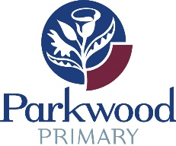

Communication Guidelines
At Parkwood Primary School we value regular communication between the school and our families. Parents/carers are encouraged to establish and maintain positive communication with teachers and the school. Teachers are available via email or using the Connect platform.

Parents/carers should discuss issues and concerns as soon as they occur. Interviews with teachers can be arranged, for a mutually convenient time, by making an appointment. Where there are tandem teachers in a class an appointment should be made with only one of the teachers.

Staff wellbeing is a priority at Parkwood Primary School and our teachers need to be able to ‘switch off’ from work and maintain a healthy work-life balance. Every effort will be made to respond to parent enquiries, generally during school hours, within a reasonable timeframe; for example, 48 hours from reading a communication on a workday. Teaching staff, including Administration, are not required to respond to communications outside of their normal working hours (8.00am – 4.00pm). If further information is required, please see the Department’s ‘Talking With my School’ document, and our school website. If a response is not received within 48 hours please send a courtesy reminder email.

To communicate a child’s absence from school, please use Connect or the email Parkwood.PS@education.wa.edu.au. Teachers may be cc’d into the email. A response to confirm receipt of an email will come from administration but not from the class teacher.

If unable to satisfactorily resolve any issue with the classroom teacher, parents/guardians are asked to make an appointment to see a Deputy Principal. The Administration team can be contacted by email at Parkwood.PS.@education.wa.edu.au or by phone on 9235 1400.

